## Setup

Before you begin, please run the following query to insert this new collection into your database.

Query:

db.movies.insertMany([

{_id: 1, title: "Wonder Woman", director: "Patty Jenkins", yearReleased: 2017, leadActors: ["Gal Gadot", "Chris Pine", "Robin Wright"], lengthInMin: 141, genre: ["Action", "Adventure", "Fantasy"], MPAA: "PG-13" },

{_id: 2, title: "Cloud Atlas", director: "Tom Tykwer", yearReleased: 2012, leadActors: ["Tom Hanks", "Halle Berry", "Hugh Grant", "Jim Broadbent", "Jim Sturgess", "Hugo Weaving"], lengthInMin: 172, genre: ["Action", "Drama", "Mystery"], MPAA: "R" },

{_id: 3, title: "Pan's Labyrinth", director: "Guillermo del Torro", yearReleased: 2006, leadActors: ["Ivana Baquero", "Ariadna Gil", "Sergi Lopez"], lengthInMin: 118, genre: ["Drama", "Fantasy", "War", "Foreign"], MPAA: "R" },

{_id: 4, title: "Gone With the Wind", director: "Victor Fleming", yearReleased: 1939, leadActors: ["Clark Gable", "Vivien Leigh", "Thomas Mitchell", "Olivia de Havilland", "Leslie Howard"], lengthInMin: 238, genre: ["Drama", "History", "Romance"], MPAA: "G" },

{_id: 5, title: "Spaceballs", director: "Mel Brooks", yearReleased: 1987, leadActors: ["Mel Brooks", "John Candy", "Rick Moranis", "Bill Pullman", "Daphne Zuniga"], lengthInMin: 96, genre: ["Adventure", "Comedy", "Sci-fi"], MPAA: "PG" },

{_id: 6, title: "Silence of the Lambs", director: "Jonathan Demme", yearReleased: 1991, leadActors: ["Jodie Foster", "Anthony Hopkins", "Anthony Heald"], lengthInMin: 118, genre: ["Crime", "Drama", "Thriller"], MPAA: "R" },

{_id: 7, title: "American History X", director: "Tony Kaye", yearReleased: 1998, leadActors: ["Edward Norton", "Edward Furlong", "Beverly D'Angelo", "Ethan Suplee"], lengthInMin: 119, genre: ["Crime", "Drama"], MPAA: "R" },

{_id: 8, title: "Psycho", director: "Alfred Hitchcock", yearReleased: 1960, leadActors: ["Anthony Perkins", "Vera Miles", "John Gavin", "Janet Leigh"], lengthInMin: 109, genre: ["Horror", "Mystery", "Thriller"], MPAA: "R" },

{_id: 9, title: "The Pianist", director: "Roman Polanski", yearReleased: 2002, leadActors: ["Adrien Brody", "Emilia Fox", "Michal Zebrowski", "Ed Stoppard"], lengthInMin: 150, genre: ["Biography", "Drama", "Music"], MPAA: "R" },

{_id: 10, title: "Gladiator", director: "Ridley Scott", yearReleased: 2000, leadActors: ["Russell Crowe", "Joaquin Phoenix", "Connie Nielsen", "Oliver Reed"], lengthInMin: 155, genre: ["Action", "Adventure", "Drama"], MPAA: "R" },

])

Results: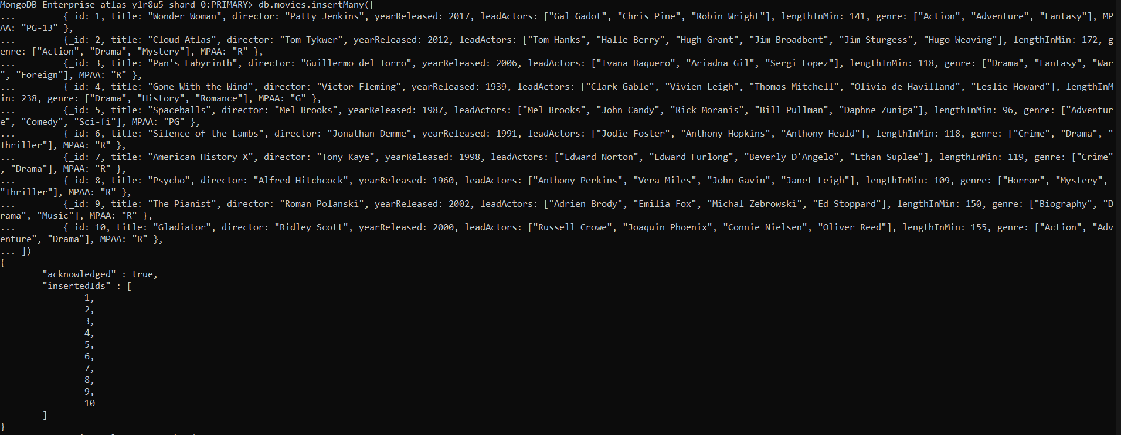

## Part 1

Run the following queries:

1. Find all movies that are longer than 2 hours.

Query:

db.movies.find({lengthInMin: {$gt: 120} })

Results:

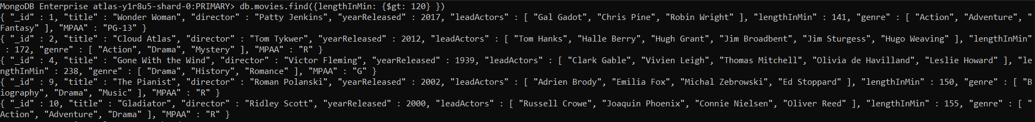

1. Find all movies that do not have Tom Hanks as a lead actor.

Query:

db.movies.find({leadActors: {$ne: "Tom Hanks"} })

Results:

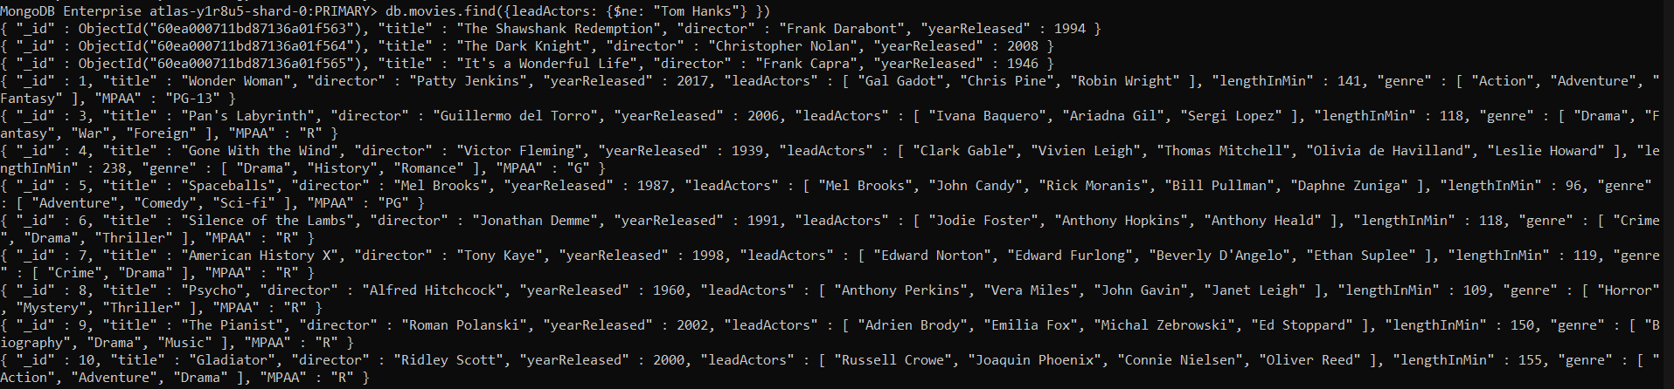

1. Find all movies that were directed by Mel Brooks.

Query:

db.movies.find({director: {$eq: "Mel Brooks"} })

Results:



1. Find all movies that are not considered Drama.

Query:

db.movies.find({genre: {$ne: "Drama"} })

Results:

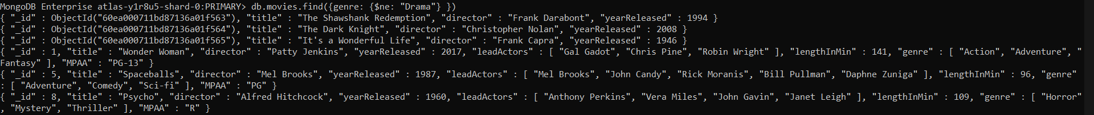

1. Find all movies that are longer than 90 minutes but less than 2 hours.

Query:

db.movies.find({$and: [{lengthInMin:{$gt: 90}}, {lengthInMin:{$lt: 120}}]})

Results:

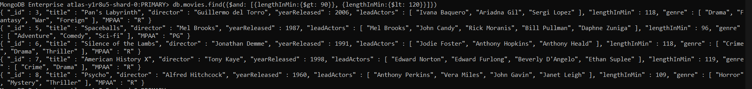

1. Find all movies that are considered Action or Adventure and return only the title of the movie.

Query:

db.movies.find({$or: [{genre: "Action"}, {genre: "Adventure"}]}, {title: 1})

Results:



## Part 2

Below is a real-life scenario. Please read this scenario and run the appropriate queries needed.

The company you work for is having a movie night for all employees, and they are trying to find the perfect movie for movie night. The problem is, so many people have different opinions, and they want to make everyone happy. Sally has very poor eyesight so cannot watch any foreign films but likes comedies and dramas. Robert hates Jodie Foster and refuses to watch any movies with her in it, but likes comedies and horror films. Stewart has somewhere to be after movie night, so he can't watch a movie longer than 2 hours; he prefers thrillers and comedies.

After running your query(ies), what movie is going to be played at movie night?

Queries:

Individual queries

db.movies.find({genre: {$ne: "Foreign"}})

db.movies.find({genre: "Comedy"})

db.movies.find({leadActors: {$ne: "Jodie Foster"}})

db.movies.find({lengthInMin: {$gt: 120}})

Combined Query:

db.movies.find({$and: [{genre: {$ne: "Foreign"}}, {genre: "Comedy"}, {leadActors: {$ne: "Jodie Foster"}}, {lengthInMin: {$lt: 120}}]})

Results:



The employees should watch the movie “Space Balls,” which meets these criteria: the film is not of foreign genre, the film is from the comedy genre, Jodie Foster is not one of the lead actors, and the film is less than 2 hours long.

## Appendix

Part 1

1. Find all movies that are longer than 2 hours.

Query:

db.movies.find({lengthInMin: {$gt: 120} }).pretty()

Result:

MongoDB Enterprise atlas-y1r8u5-shard-0:PRIMARY> db.movies.find({lengthInMin: {$gt: 120} }).pretty()

{

"_id" : 1,

"title" : "Wonder Woman",

"director" : "Patty Jenkins",

"yearReleased" : 2017,

"leadActors" : [

"Gal Gadot",

"Chris Pine",

"Robin Wright"

],

"lengthInMin" : 141,

"genre" : [

"Action",

"Adventure",

"Fantasy"

],

"MPAA" : "PG-13"

}

{

"_id" : 2,

"title" : "Cloud Atlas",

"director" : "Tom Tykwer",

"yearReleased" : 2012,

"leadActors" : [

"Tom Hanks",

"Halle Berry",

"Hugh Grant",

"Jim Broadbent",

"Jim Sturgess",

"Hugo Weaving"

],

"lengthInMin" : 172,

"genre" : [

"Action",

"Drama",

"Mystery"

],

"MPAA" : "R"

}

{

"_id" : 4,

"title" : "Gone With the Wind",

"director" : "Victor Fleming",

"yearReleased" : 1939,

"leadActors" : [

"Clark Gable",

"Vivien Leigh",

"Thomas Mitchell",

"Olivia de Havilland",

"Leslie Howard"

],

"lengthInMin" : 238,

"genre" : [

"Drama",

"History",

"Romance"

],

"MPAA" : "G"

}

{

"_id" : 9,

"title" : "The Pianist",

"director" : "Roman Polanski",

"yearReleased" : 2002,

"leadActors" : [

"Adrien Brody",

"Emilia Fox",

"Michal Zebrowski",

"Ed Stoppard"

],

"lengthInMin" : 150,

"genre" : [

"Biography",

"Drama",

"Music"

],

"MPAA" : "R"

}

{

"_id" : 10,

"title" : "Gladiator",

"director" : "Ridley Scott",

"yearReleased" : 2000,

"leadActors" : [

"Russell Crowe",

"Joaquin Phoenix",

"Connie Nielsen",

"Oliver Reed"

],

"lengthInMin" : 155,

"genre" : [

"Action",

"Adventure",

"Drama"

],

"MPAA" : "R"

}

1. Find all movies that do not have Tom Hanks as a lead actor.

Query:

db.movies.find({leadActors: {$ne: "Tom Hanks"} }).pretty()

Results:

MongoDB Enterprise atlas-y1r8u5-shard-0:PRIMARY> db.movies.find({leadActors: {$ne: "Tom Hanks"} }).pretty()

{

"_id" : ObjectId("60ea000711bd87136a01f563"),

"title" : "The Shawshank Redemption",

"director" : "Frank Darabont",

"yearReleased" : 1994

}

{

"_id" : ObjectId("60ea000711bd87136a01f564"),

"title" : "The Dark Knight",

"director" : "Christopher Nolan",

"yearReleased" : 2008

}

{

"_id" : ObjectId("60ea000711bd87136a01f565"),

"title" : "It's a Wonderful Life",

"director" : "Frank Capra",

"yearReleased" : 1946

}

{

"_id" : 1,

"title" : "Wonder Woman",

"director" : "Patty Jenkins",

"yearReleased" : 2017,

"leadActors" : [

"Gal Gadot",

"Chris Pine",

"Robin Wright"

],

"lengthInMin" : 141,

"genre" : [

"Action",

"Adventure",

"Fantasy"

],

"MPAA" : "PG-13"

}

{

"_id" : 3,

"title" : "Pan's Labyrinth",

"director" : "Guillermo del Torro",

"yearReleased" : 2006,

"leadActors" : [

"Ivana Baquero",

"Ariadna Gil",

"Sergi Lopez"

],

"lengthInMin" : 118,

"genre" : [

"Drama",

"Fantasy",

"War",

"Foreign"

],

"MPAA" : "R"

}

{

"_id" : 4,

"title" : "Gone With the Wind",

"director" : "Victor Fleming",

"yearReleased" : 1939,

"leadActors" : [

"Clark Gable",

"Vivien Leigh",

"Thomas Mitchell",

"Olivia de Havilland",

"Leslie Howard"

],

"lengthInMin" : 238,

"genre" : [

"Drama",

"History",

"Romance"

],

"MPAA" : "G"

}

{

"_id" : 5,

"title" : "Spaceballs",

"director" : "Mel Brooks",

"yearReleased" : 1987,

"leadActors" : [

"Mel Brooks",

"John Candy",

"Rick Moranis",

"Bill Pullman",

"Daphne Zuniga"

],

"lengthInMin" : 96,

"genre" : [

"Adventure",

"Comedy",

"Sci-fi"

],

"MPAA" : "PG"

}

{

"_id" : 6,

"title" : "Silence of the Lambs",

"director" : "Jonathan Demme",

"yearReleased" : 1991,

"leadActors" : [

"Jodie Foster",

"Anthony Hopkins",

"Anthony Heald"

],

"lengthInMin" : 118,

"genre" : [

"Crime",

"Drama",

"Thriller"

],

"MPAA" : "R"

}

{

"_id" : 7,

"title" : "American History X",

"director" : "Tony Kaye",

"yearReleased" : 1998,

"leadActors" : [

"Edward Norton",

"Edward Furlong",

"Beverly D'Angelo",

"Ethan Suplee"

],

"lengthInMin" : 119,

"genre" : [

"Crime",

"Drama"

],

"MPAA" : "R"

}

{

"_id" : 8,

"title" : "Psycho",

"director" : "Alfred Hitchcock",

"yearReleased" : 1960,

"leadActors" : [

"Anthony Perkins",

"Vera Miles",

"John Gavin",

"Janet Leigh"

],

"lengthInMin" : 109,

"genre" : [

"Horror",

"Mystery",

"Thriller"

],

"MPAA" : "R"

}

{

"_id" : 9,

"title" : "The Pianist",

"director" : "Roman Polanski",

"yearReleased" : 2002,

"leadActors" : [

"Adrien Brody",

"Emilia Fox",

"Michal Zebrowski",

"Ed Stoppard"

],

"lengthInMin" : 150,

"genre" : [

"Biography",

"Drama",

"Music"

],

"MPAA" : "R"

}

{

"_id" : 10,

"title" : "Gladiator",

"director" : "Ridley Scott",

"yearReleased" : 2000,

"leadActors" : [

"Russell Crowe",

"Joaquin Phoenix",

"Connie Nielsen",

"Oliver Reed"

],

"lengthInMin" : 155,

"genre" : [

"Action",

"Adventure",

"Drama"

],

"MPAA" : "R"

}

1. Find all movies that were directed by Mel Brooks.

Query:

db.movies.find({director: {$eq: "Mel Brooks"} }).pretty()

Results:

MongoDB Enterprise atlas-y1r8u5-shard-0:PRIMARY> db.movies.find({director: {$eq: "Mel Brooks"} }).pretty()

{

"_id" : 5,

"title" : "Spaceballs",

"director" : "Mel Brooks",

"yearReleased" : 1987,

"leadActors" : [

"Mel Brooks",

"John Candy",

"Rick Moranis",

"Bill Pullman",

"Daphne Zuniga"

],

"lengthInMin" : 96,

"genre" : [

"Adventure",

"Comedy",

"Sci-fi"

],

"MPAA" : "PG"

}

1. Find all movies that are not considered Drama.

Query:

db.movies.find({genre: {$ne: "Drama"} }).pretty()

Results:

MongoDB Enterprise atlas-y1r8u5-shard-0:PRIMARY> db.movies.find({genre: {$ne: "Drama"} }).pretty()

{

"_id" : ObjectId("60ea000711bd87136a01f563"),

"title" : "The Shawshank Redemption",

"director" : "Frank Darabont",

"yearReleased" : 1994

}

{

"_id" : ObjectId("60ea000711bd87136a01f564"),

"title" : "The Dark Knight",

"director" : "Christopher Nolan",

"yearReleased" : 2008

}

{

"_id" : ObjectId("60ea000711bd87136a01f565"),

"title" : "It's a Wonderful Life",

"director" : "Frank Capra",

"yearReleased" : 1946

}

{

"_id" : 1,

"title" : "Wonder Woman",

"director" : "Patty Jenkins",

"yearReleased" : 2017,

"leadActors" : [

"Gal Gadot",

"Chris Pine",

"Robin Wright"

],

"lengthInMin" : 141,

"genre" : [

"Action",

"Adventure",

"Fantasy"

],

"MPAA" : "PG-13"

}

{

"_id" : 5,

"title" : "Spaceballs",

"director" : "Mel Brooks",

"yearReleased" : 1987,

"leadActors" : [

"Mel Brooks",

"John Candy",

"Rick Moranis",

"Bill Pullman",

"Daphne Zuniga"

],

"lengthInMin" : 96,

"genre" : [

"Adventure",

"Comedy",

"Sci-fi"

],

"MPAA" : "PG"

}

{

"_id" : 8,

"title" : "Psycho",

"director" : "Alfred Hitchcock",

"yearReleased" : 1960,

"leadActors" : [

"Anthony Perkins",

"Vera Miles",

"John Gavin",

"Janet Leigh"

],

"lengthInMin" : 109,

"genre" : [

"Horror",

"Mystery",

"Thriller"

],

"MPAA" : "R"

}

1. Find all movies that are longer than 90 minutes but less than 2 hours.

Query:

db.movies.find({$and: [{lengthInMin:{$gt: 90}}, {lengthInMin:{$lt: 120}}]}).pretty()

Results:

MongoDB Enterprise atlas-y1r8u5-shard-0:PRIMARY> db.movies.find({$and: [{lengthInMin:{$gt: 90}}, {lengthInMin:{$lt: 120}}]}).pretty()

{

"_id" : 3,

"title" : "Pan's Labyrinth",

"director" : "Guillermo del Torro",

"yearReleased" : 2006,

"leadActors" : [

"Ivana Baquero",

"Ariadna Gil",

"Sergi Lopez"

],

"lengthInMin" : 118,

"genre" : [

"Drama",

"Fantasy",

"War",

"Foreign"

],

"MPAA" : "R"

}

{

"_id" : 5,

"title" : "Spaceballs",

"director" : "Mel Brooks",

"yearReleased" : 1987,

"leadActors" : [

"Mel Brooks",

"John Candy",

"Rick Moranis",

"Bill Pullman",

"Daphne Zuniga"

],

"lengthInMin" : 96,

"genre" : [

"Adventure",

"Comedy",

"Sci-fi"

],

"MPAA" : "PG"

}

{

"_id" : 6,

"title" : "Silence of the Lambs",

"director" : "Jonathan Demme",

"yearReleased" : 1991,

"leadActors" : [

"Jodie Foster",

"Anthony Hopkins",

"Anthony Heald"

],

"lengthInMin" : 118,

"genre" : [

"Crime",

"Drama",

"Thriller"

],

"MPAA" : "R"

}

{

"_id" : 7,

"title" : "American History X",

"director" : "Tony Kaye",

"yearReleased" : 1998,

"leadActors" : [

"Edward Norton",

"Edward Furlong",

"Beverly D'Angelo",

"Ethan Suplee"

],

"lengthInMin" : 119,

"genre" : [

"Crime",

"Drama"

],

"MPAA" : "R"

}

{

"_id" : 8,

"title" : "Psycho",

"director" : "Alfred Hitchcock",

"yearReleased" : 1960,

"leadActors" : [

"Anthony Perkins",

"Vera Miles",

"John Gavin",

"Janet Leigh"

],

"lengthInMin" : 109,

"genre" : [

"Horror",

"Mystery",

"Thriller"

],

"MPAA" : "R"

}

1. Find all movies that are considered Action or Adventure and return only the title of the movie.

Query:

db.movies.find({$or: [{genre: "Action"}, {genre: "Adventure"}]}, {title: 1}).pretty()

Results:

{ "_id" : 1, "title" : "Wonder Woman" }

{ "_id" : 2, "title" : "Cloud Atlas" }

{ "_id" : 5, "title" : "Spaceballs" }

{ "_id" : 10, "title" : "Gladiator" }

Part 2

The company you work for is having a movie night for all employees, and they are trying to find the perfect movie for movie night. The problem is, so many people have different opinions, and they want to make everyone happy. Sally has very poor eyesight so cannot watch any foreign films but likes comedies and dramas. Robert hates Jodie Foster and refuses to watch any movies with her in it, but likes comedies and horror films. Stewart has somewhere to be after movie night, so he can't watch a movie longer than 2 hours; he prefers thrillers and comedies.

After running your query(ies), what movie is going to be played at movie night?

Query:

db.movies.find({$and: [{genre: {$ne: "Foreign"}}, {genre: "Comedy"}, {leadActors: {$ne: "Jodie Foster"}}, {lengthInMin: {$lt: 120}}]}).pretty()

Results:

MongoDB Enterprise atlas-y1r8u5-shard-0:PRIMARY> db.movies.find({$and: [{genre: {$ne: "Foreign"}}, {genre: "Comedy"}, {leadActors: {$ne: "Jodie Foster"}}, {lengthInMin: {$lt: 120}}]}).pretty()

{

"_id" : 5,

"title" : "Spaceballs",

"director" : "Mel Brooks",

"yearReleased" : 1987,

"leadActors" : [

"Mel Brooks",

"John Candy",

"Rick Moranis",

"Bill Pullman",

"Daphne Zuniga"

],

"lengthInMin" : 96,

"genre" : [

"Adventure",

"Comedy",

"Sci-fi"

],

"MPAA" : "PG"

}